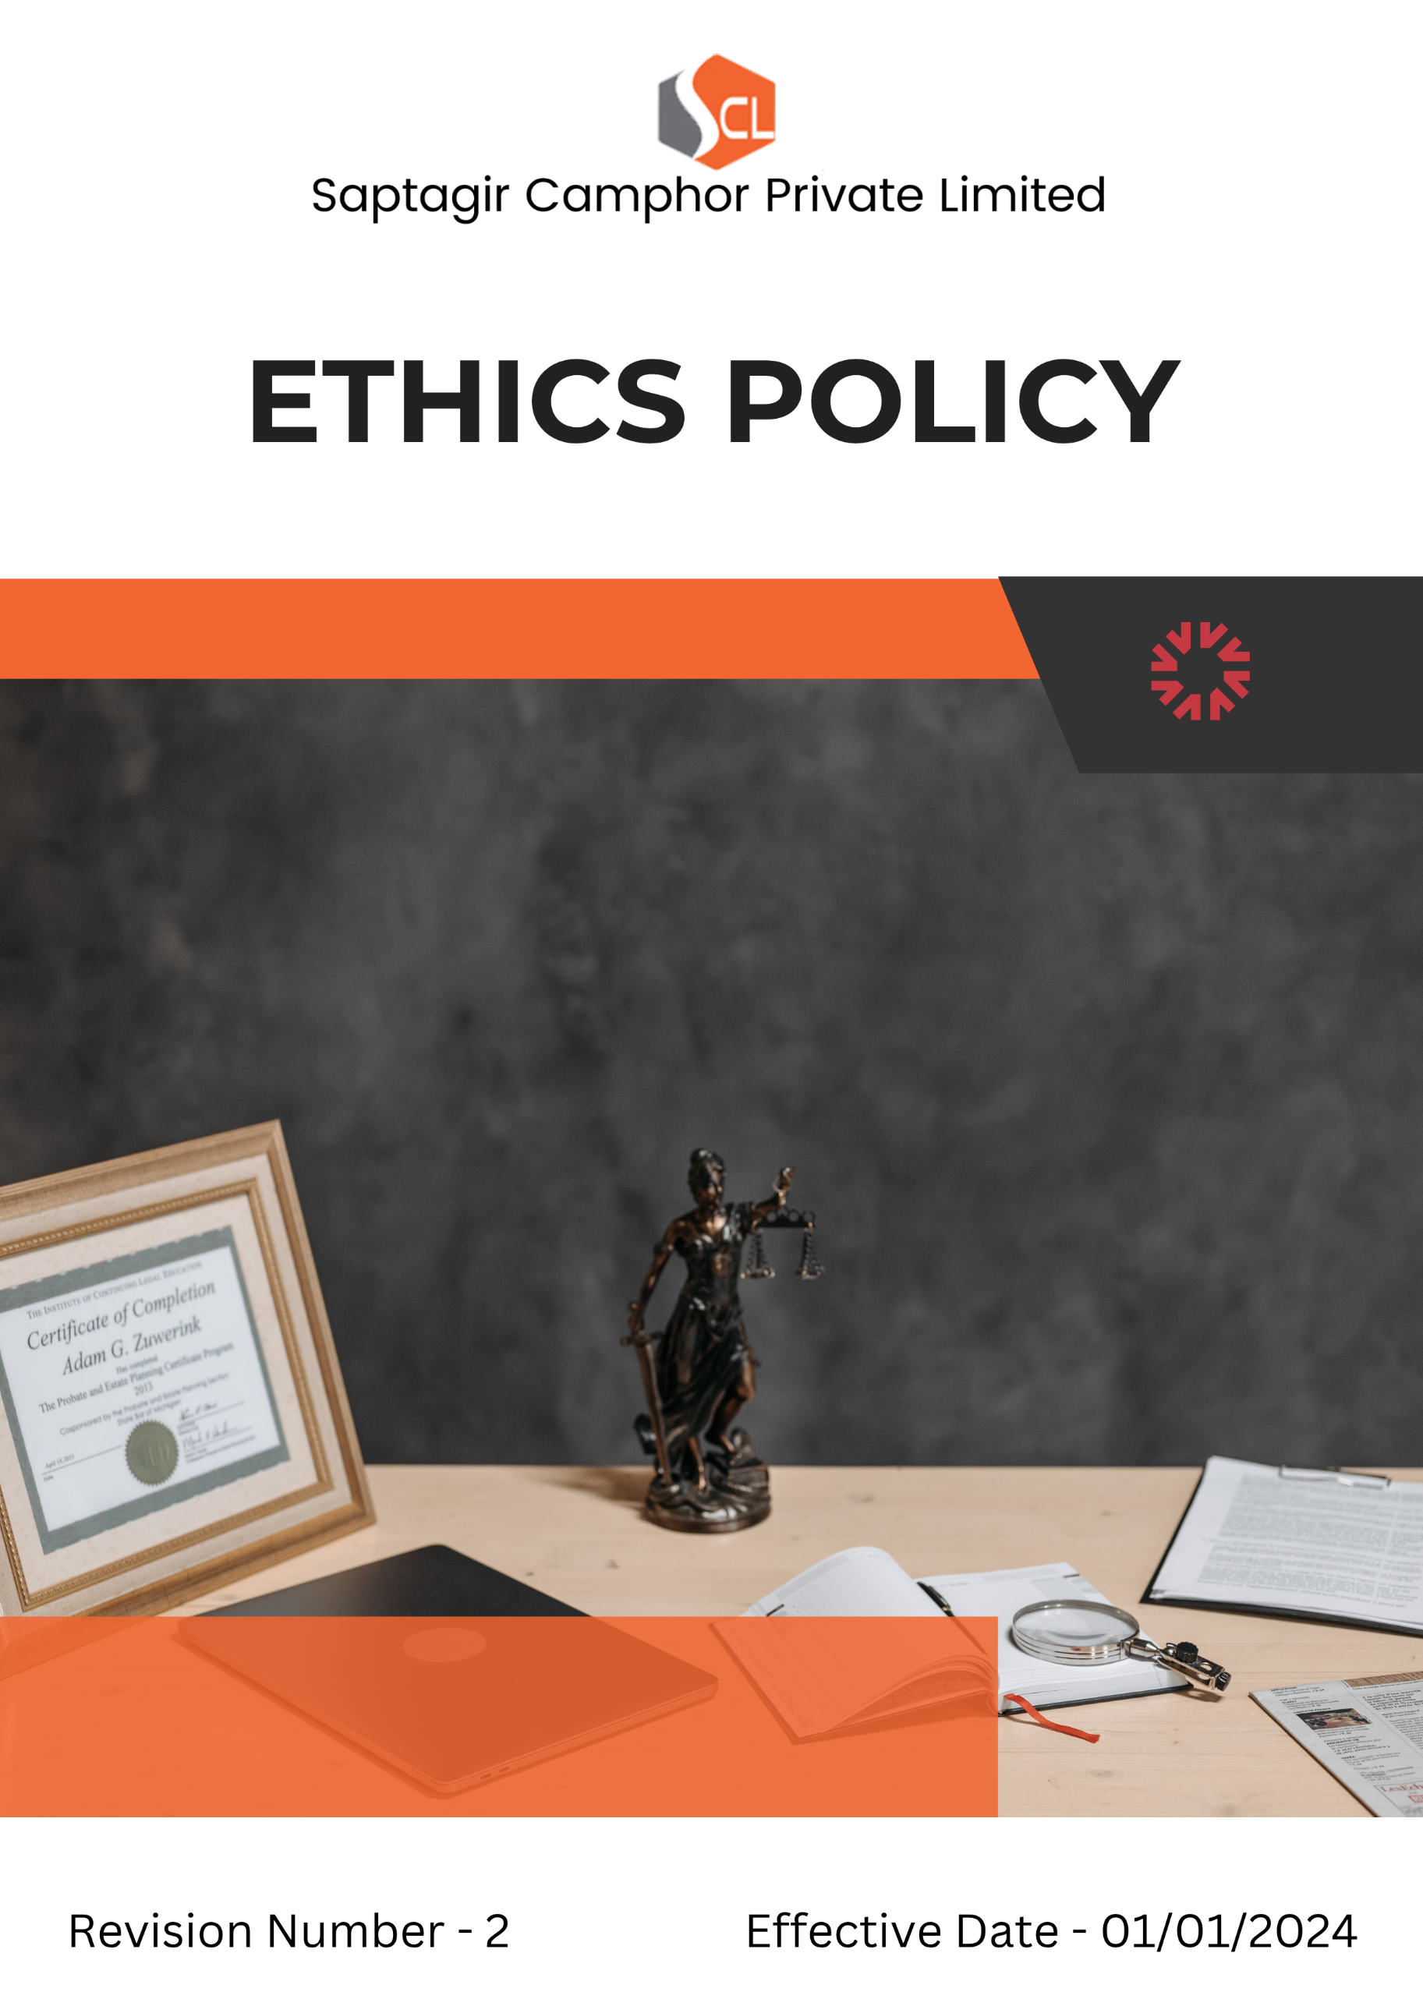
Index

❖ Introduction 3
❖ Scope 3
❖ Ethics Commitment 4
❖ Quantitative Targets 5
❖ Action Framework 6
❖ Roles and Responsibilities 6
❖ Ethical Compliance Framework: Do’s and Don’ts Across Key Risk Areas 7
❖ Disciplinary Measures 8
❖ Monitoring and Reporting 9
❖ Communication and Transparency 9
❖ Continuous Improvement 10
❖ SDGs (Sustainable Development Goals) Covered in the Ethics Policy 10
❖ Review 10
❖ Employee Acknowledgment: Ethics Policy 11

Introduction
At Saptagir Camphor Private Limited (SCPL), we are committed to conducting our business with the highest standards of ethics, transparency, and integrity. As a leading manufacturer of camphor and terpene-based products, we recognize that ethical conduct is fundamental to building trust with our stakeholders and maintaining our reputation. This Ethics Policy serves as a guiding framework for our employees, contractors, suppliers, and business partners, encouraging responsible decision-making, preventing unethical behavior, and fostering a culture of accountability and respect. We expect all individuals associated with SCPL to uphold the principles outlined in this policy and ensure compliance with all applicable laws, industry regulations, and internal standards, thereby supporting the long-term sustainability of our operations and our commitment to ethical excellence.

Scope
This policy applies to all Saptagir Camphor Private Limited (SCPL) employees, Workers, Contractors, Sub-Contractors, suppliers, partners, and stakeholders across all operational locations. It encompasses our manufacturing sites, corporate offices, and any other business operations, and extends to our interactions with clients, vendors, regulators, and the wider community.

Sr. No. | Address
1. | Vaishnavi's Cynosure, 5th Floor, Telecom Nagar, Gachibowli, Hyderabad - 500032
2 | 13.5 Kms, Gooty Road, B. Kothapalli - 515731, Anantapur (Dist) A.P. INDIA
3 | 3C/2, Mariamma Street, Near Teppakulam, New Ramnad Road, Madurai - 625009, Tamil Nadu, India
4 | No. 106/43B, Jeeva Nagar, (Velan Nagar 1st Street) E.N. Road, Korukkupet, Chennai - 600021, Tamil Nadu, India
5 | No. 51, 5th Cross, 2nd Main Road, Chamarajpet, Bangalore - 560018
6 | 54-3/1-5A, 9th Block, Plot No.44, 2nd Cross Rd, J. Auto Nagar, Auto Nagar, Vijayawada, Andhra Pradesh - 520007

Ethics Commitment
Saptagir Camphor Private Limited (SCPL) is dedicated to ethical business practices and is committed to upholding the following principles:
- Corruption: SCPL has a zero-tolerance policy toward corruption in all its forms, including bribery, extortion, and illicit payments. All employees and partners are required to act with integrity and avoid any activity that could be perceived as corrupt. Robust internal controls have been implemented to detect and prevent corrupt practices at all levels of the organization.
- Conflict of Interest: All employees must avoid situations where personal interests could conflict, or appear to conflict, with the interests of SCPL. Any potential conflict must be disclosed immediately, and SCPL’s leadership will take appropriate, transparent steps to resolve such matters ethically.
- Fraud Prevention: SCPL actively works to prevent, detect, and address fraud through a structured fraud management system that includes internal audits, reporting mechanisms, and strict disciplinary measures. Employees are obligated to report any suspicious activity to designated company authorities.
- Money Laundering: SCPL is committed to preventing money laundering and adheres to all applicable anti-money laundering (AML) regulations. We have implemented thorough due diligence procedures for financial transactions, customer verification, and ongoing monitoring to ensure regulatory compliance. Employees and partners are expected to report any suspicious financial activities.
- Anti-Competitive Practices: SCPL ensures that it operates in a fair and competitive manner, complying with all relevant antitrust and competition laws. We do not engage in practices such as price-fixing, collusion, or bid-rigging, and strive to uphold the integrity of the marketplace.
- Information Security: SCPL recognizes the importance of information security and the protection of data. We maintain comprehensive policies to secure confidential and sensitive information from unauthorized access, misuse, or disclosure. Our information security framework includes regular risk assessments, employee training, and secure data handling protocols to protect the interests of the company, our employees, and our customers.

Quantitative Targets
- Sets 2022-23 as the baseline for tracking our ethical compliance and performance.

- Corruption
- Conduct annual anti-corruption training for 100% of employees by FY 2027-28.
- Maintain zero confirmed incidents of corruption or bribery across all operations by FY 2027-28.
- Conduct annual anti-corruption risk assessment which cover our 100% of sites by FY 2027-28
- Conflict of Interest
- Implement a conflict-of-interest declaration system for 100% of employees by FY 2027-28.
- Maintain 100% of employees trained annually on Conflict-of-Interest Policy
- Resolve 100% of disclosed conflicts of interest within 30 days of reporting by FY 2027-28.
- Fraud Prevention
- Increase internal fraud detection rates by 10% by FY 2027-28 through enhanced audit systems and reporting channels.
- Conduct biannual fraud prevention workshops for all employees.
- Money Laundering
- Maintain 100% compliance with anti-money laundering regulations by FY 2027-28 through regular training and monitoring.
- Conduct Annually information money laundering assessments across all departments.
- Conduct annual AML audits across all financial transactions by FY 2027-28.
- Anti-Competitive Practices
- Maintain full compliance with all applicable competition laws by FY 2027-28.
- Conduct annual audits to ensure no anti-competitive practices are occurring within SCPL’s operations or partnerships.

- Information Security
- Maintain 100% of employees trained annually on Information Security Policy.
- Conduct annual information security risk assessments covering 100% of all departments by FY 2027-28.
- Ensure a reduction of 20% in information security incidents by FY 2027-28 through employee training and technology upgrades.
- Maintain 100% of information assets correctly classified as Restricted, Confidential, Unrestricted, Public.

Action Framework
- Corruption Prevention: SCPL conducts internal and external audits regularly to identify and mitigate corruption risks. Employees are trained to recognize and report suspicious behavior related to bribery or unethical conduct.
- Conflict of Interest Disclosure: Employees are required to declare any potential conflicts of interest through a formal system. SCPL leadership ensures all disclosures are ethically and promptly addressed.
- Fraud Management System: SCPL has a comprehensive system for fraud detection and reporting, supported by audits and frequent fraud awareness sessions. Confidential reporting channels are available to all employees.
- AML Compliance: Due diligence processes such as transaction monitoring, customer verification, and annual AML audits are implemented to ensure compliance with all AML regulations.
- Fair Competition Monitoring: SCPL conducts regular audits to ensure compliance with antitrust regulations and to promote fair competition among stakeholders.
- Information Security Measures: SCPL utilizes a comprehensive information security management system, including cybersecurity assessments, employee training, secure data handling, and encryption to protect critical information.

Roles and Responsibilities
- Compliance Officer: Oversees implementation of SCPL’s Ethics Policy, monitors compliance, and addresses risks related to corruption, fraud, AML, and conflicts of interest.
- Internal Audit Team: Conducts audits covering fraud, anti-competitive behaviour, and financial transparency to test and strengthen internal controls.
- Information Security Manager: Manages information protection strategies and oversees efforts to prevent data breaches and ensure data integrity.
- Employees: Expected to adhere to SCPL’s ethical standards, participate in training, and report any violations of the policy.

Ethical Compliance Framework: Do’s and Don’ts Across Key Risk Areas
Category | Do’s | Don’ts
Anti-Corruption and Fraud Prevention | - Report any suspected bribery, fraud, or unethical conduct to the Compliance Officer or through the Whistleblower Procedure.  - Maintain transparent and accurate records of all financial transactions.  - Decline gifts or incentives from suppliers that could influence business decisions. | - Do not offer or accept bribes in any form.  - Do not falsify or manipulate financial records.  - Do not ignore or withhold information regarding potential corruption risks.
Conflict of Interest Management | - Disclose any personal or financial relationships that could create a conflict of interest.  - Seek approval before engaging in any external business relationships.  - Follow company procedures for reporting conflicts of interest. | - Do not make decisions that personally benefit you at the expense of the company.  - Do not engage in business with direct competitors without approval.  - Do not misuse company resources for personal gain.
Money Laundering Prevention | - Report any suspicious transactions to the compliance department.  - Conduct due diligence before engaging with new business partners.  - Maintain accurate financial records and transaction logs. | - Do not process or approve transactions that lack clear business justification.  - Do not ignore red flags related to suspicious financial activities.  - Do not engage in structuring transactions to evade reporting requirements.
Anti-Competitive Practice Avoidance | - Compete fairly and ethically in the marketplace.  - Follow all applicable competition laws and regulations.  - Ensure transparency in negotiations and pricing strategies. | - Do not engage in price-fixing, bid-rigging, or market allocation schemes.  - Do not discuss competitive pricing strategies with competitors.  - Do not misuse market influence to eliminate competition unfairly.
Information Security & Data Protection | - Follow company cybersecurity policies to protect sensitive data.  - Use strong passwords and enable multi-factor authentication where required.  - Report any suspicious emails, phishing attempts, or data breaches immediately. | - Do not share confidential company data with unauthorized individuals.  - Do not use personal devices to store or transmit company-sensitive information.

Disciplinary Measures
SCPL enforces strict disciplinary actions for violations of this Ethics Policy, ensuring all employees and partners understand the consequences of unethical behavior. Actions include:
- Verbal or Written Warning
- Issued for minor violations or first-time offenses. Employees receive a formal warning outlining the nature of the violation and the corrective actions required to prevent future incidents.
- Suspension
- Employees may be temporarily suspended from their duties for repeated violations or more serious offenses. This may also apply in cases of negligence, such as failure to report unethical conduct.
- Termination of Employment or Contracts
- In cases of severe misconduct—such as fraud, bribery, corruption, or conflicts of interest that compromise SCPL’s integrity—immediate termination of employment or contracts may be enforced. This includes violations of legal obligations or actions that damage the company’s reputation.
- Legal Action
- Where a violation constitutes a breach of the law (e.g., fraud, money laundering, or corruption), SCPL may pursue legal action. This includes reporting the incident to law enforcement authorities and initiating criminal or civil proceedings as appropriate.
- Restitution and Financial Penalties
- For financial misconduct or fraud, SCPL may require restitution from the responsible party to recover financial losses. Contractors or partners found in breach of ethical obligations may also face financial penalties.
- Training and Rehabilitation Programs
- In cases deemed correctable, employees may be required to undergo ethics training or participate in rehabilitation programs. These measures aim to reinforce understanding of ethical expectations and prevent future misconduct and are typically applied alongside warnings or suspensions.
SCPL’s disciplinary framework aims not only to address unethical behaviour but also to foster a culture of integrity, responsibility, and continuous ethical improvement.

Monitoring and Reporting
- Ethics Hotline: SCPL provides a confidential hotline for employees to report violations or concerns without fear of retaliation.
- Internal and External Audits: Scheduled audits ensure continued adherence to anti-corruption, AML, antitrust, and fraud prevention regulations.
- Incident Reporting: All violations are investigated, and corrective action is taken promptly.

Communication and Transparency
- The Ethics Policy is available on SCPL’s website and is regularly communicated through internal channels.
- Employees are encouraged to raise concerns and use anonymous reporting tools to maintain an open ethical dialogue.

Continuous Improvement
SCPL remains committed to improving its ethics framework and regularly reviews and revises its Ethics Policy in response to legal changes, emerging risks, and stakeholder expectations. Our ethical commitment supports sustainable growth and long-term trust.

SDGs (Sustainable Development Goals) Covered in the Ethics Policy




Review
The Compliance Officer will review this Ethics Policy annually. Updates will be informed by feedback, regulatory changes, and internal evaluations. Annual progress against targets will also be assessed.

Approved By:

Designation:

Last Review Date: 01/04/2026
Next Review Date: 01/04/2027

Employee Acknowledgment: Ethics Policy
I, acknowledge that I have received, read, and understood the Ethics Policy of Saptagir Camphor Private Limited (SCPL). I am aware of the company’s ethical principles and its commitment to preventing corruption, fraud, conflicts of interest, and ensuring compliance with anti-money laundering and antitrust regulations.
I understand my responsibility to uphold these standards and commit to reporting any violations through appropriate channels. I recognize that compliance with this policy is a condition of my continued employment or partnership with SCPL.

Employee Name:

Employee Signature:

Date:

